Project Title
Deploying a Gaming Zone Web Application on AWS EC2 Using Apache Web Server

Project Objective
The objective of this project is to gain practical experience with Amazon Web Services (AWS) by launching an EC2 instance, configuring security groups, connecting via SSH, installing the Apache2 web server, and deploying a custom Gaming Zone web application.
By completing this project, I learned how to manage cloud infrastructure, configure Linux servers, and host a static website that can be accessed through a web browser.

Prerequisites
- Basic knowledge of Linux commands
- Active AWS account
- Understanding of ports and security groups
- SSH client (Terminal / PuTTY)

Project Tasks & Implementation

Task 1: Create an EC2 Instance
- Logged in to AWS Management Console
- Navigated to EC2 → Launch Instance
- Selected Ubuntu Server 22.04 LTS
- Chose t2.micro instance type
- Created a key pair for SSH access
Outcome: EC2 instance successfully launched and running.
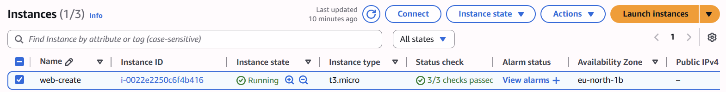

Task 2: Configure Security Groups
Configured inbound rules as follows:
Protocol | Port | Source
SSH | 22 | My IP
HTTP | 80 | 0.0.0.0/0
Outcome: Secure SSH access and public web access enabled
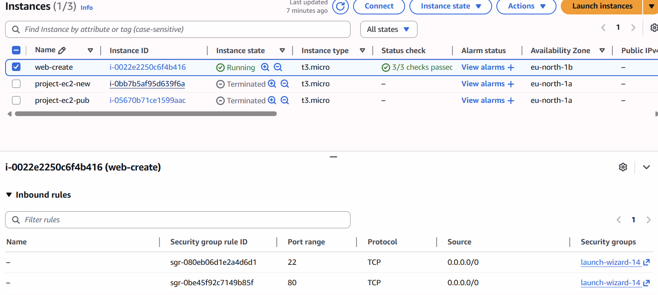

Task 3: Connect to EC2 Using SSH
Connected to the EC2 instance using the command:
ssh -i my-key.pem ubuntu@<public-ip>
Outcome: Successfully logged into the EC2 server.
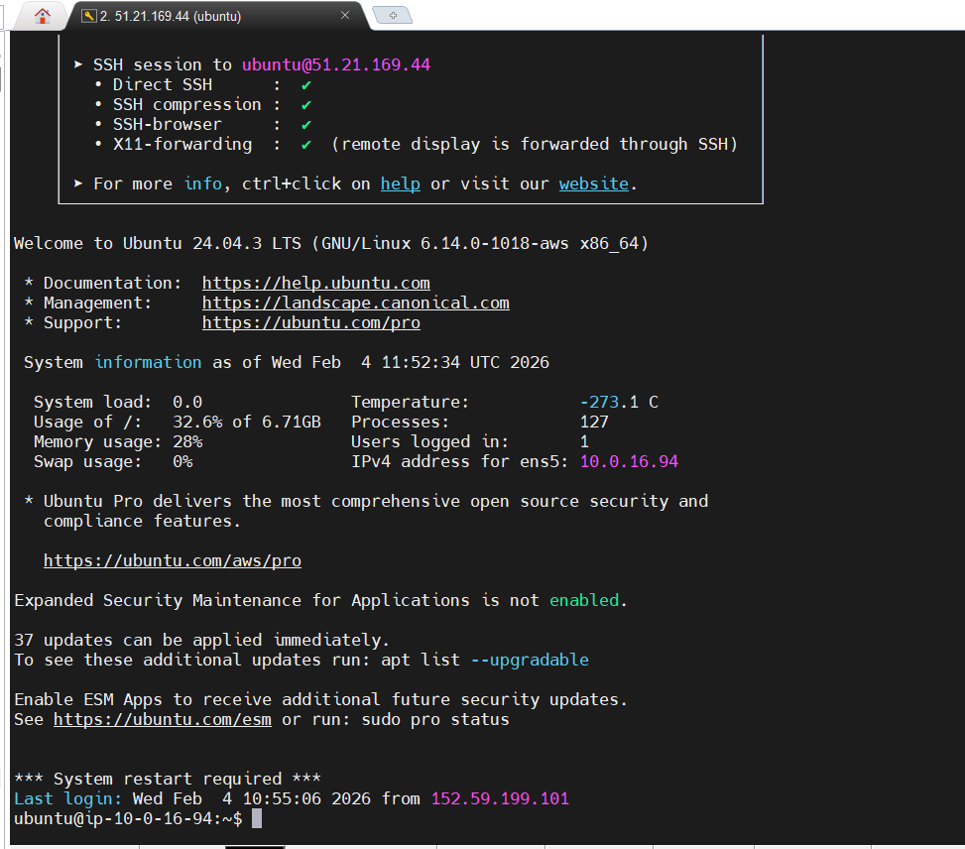

Task 4: Install and Start Apache2
Updated packages and installed Apache:
sudo apt update
sudo apt install apache2 -y
sudo systemctl start apache2
sudo systemctl enable apache2
Verified Apache status:
sudo systemctl status apache2
Outcome: Apache2 web server running successfully.
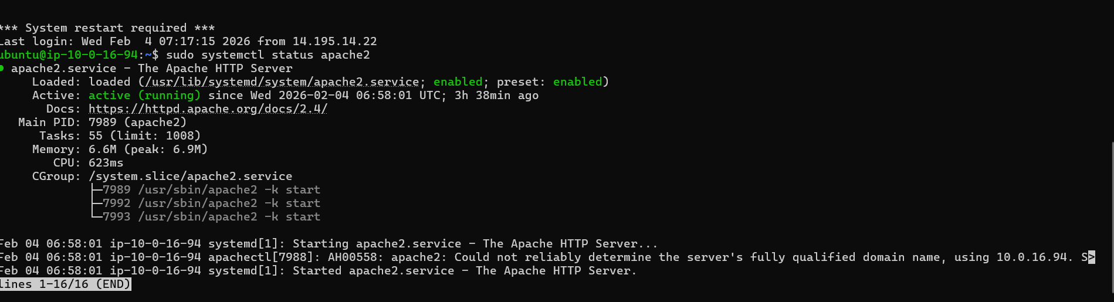

Task 5: Test HTTP Access
- Opened browser
- Entered EC2 public IP
Outcome: Apache default page displayed successfully.
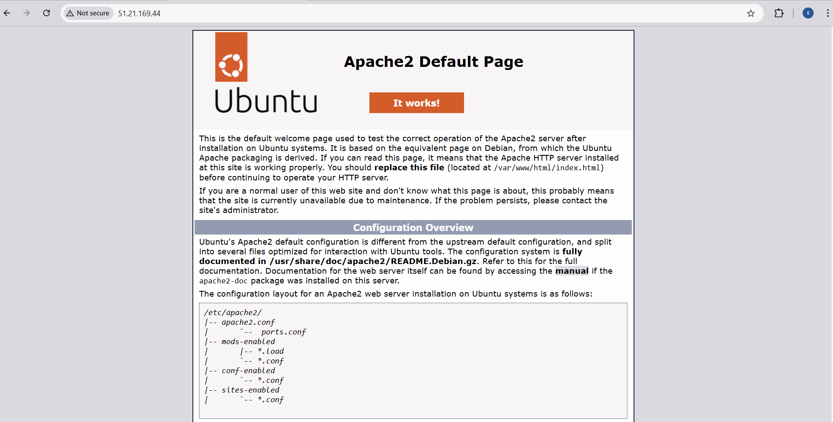

Task 6: Deploy Gaming Zone Web Application
Navigated to Apache root directory:
cd /var/www/html
sudo nano index.html
Replaced the default page with the Gaming Zone web application.

Deployed Web Application Code (index.html)
<!DOCTYPE html>
<html lang="en">
<head>
<meta charset="UTF-8">
<title>Gaming Zone</title>
<style>
body {
margin: 0;
font-family: Arial, sans-serif;
background: linear-gradient(135deg, #0f2027, #203a43, #2c5364);
color: white;
text-align: center;
}
header {
padding: 30px;
background-color: rgba(0, 0, 0, 0.6);
}
header h1 {
font-size: 40px;
margin: 0;
}
.games {
display: flex;
justify-content: center;
gap: 20px;
padding: 40px;
flex-wrap: wrap;
}
.card {
background-color: rgba(255, 255, 255, 0.1);
width: 220px;
padding: 20px;
border-radius: 15px;
box-shadow: 0 0 15px rgba(0, 0, 0, 0.5);
transition: transform 0.3s;
}
.card:hover {
transform: scale(1.08);
}
.card img {
width: 100%;
border-radius: 10px;
}
button {
margin-top: 10px;
padding: 10px 20px;
border: none;
border-radius: 20px;
background-color: #ff9800;
color: black;
font-weight: bold;
cursor: pointer;
}
button:hover {
background-color: #ffc107;
}
footer {
padding: 15px;
background-color: rgba(0, 0, 0, 0.6);
font-size: 14px;
}
</style>
</head>
<body>

<header>
<h1>🎮 Gaming Zone</h1>
<p>Play. Compete. Win.</p>
</header>

<section class="games">
<div class="card">
<img src="https://via.placeholder.com/200x120" alt="Game 1">
<h3>Racing Game</h3>
<button>Play Now</button>
</div>
<div class="card">
<img src="https://via.placeholder.com/200x120" alt="Game 2">
<h3>Shooting Game</h3>
<button>Play Now</button>
</div>
<div class="card">
<img src="https://via.placeholder.com/200x120" alt="Game 3">
<h3>Adventure Game</h3>
<button>Play Now</button>
</div>
</section>

<footer>
© 2026 Gaming Zone | All Rights Reserved
</footer>

</body>
</html>
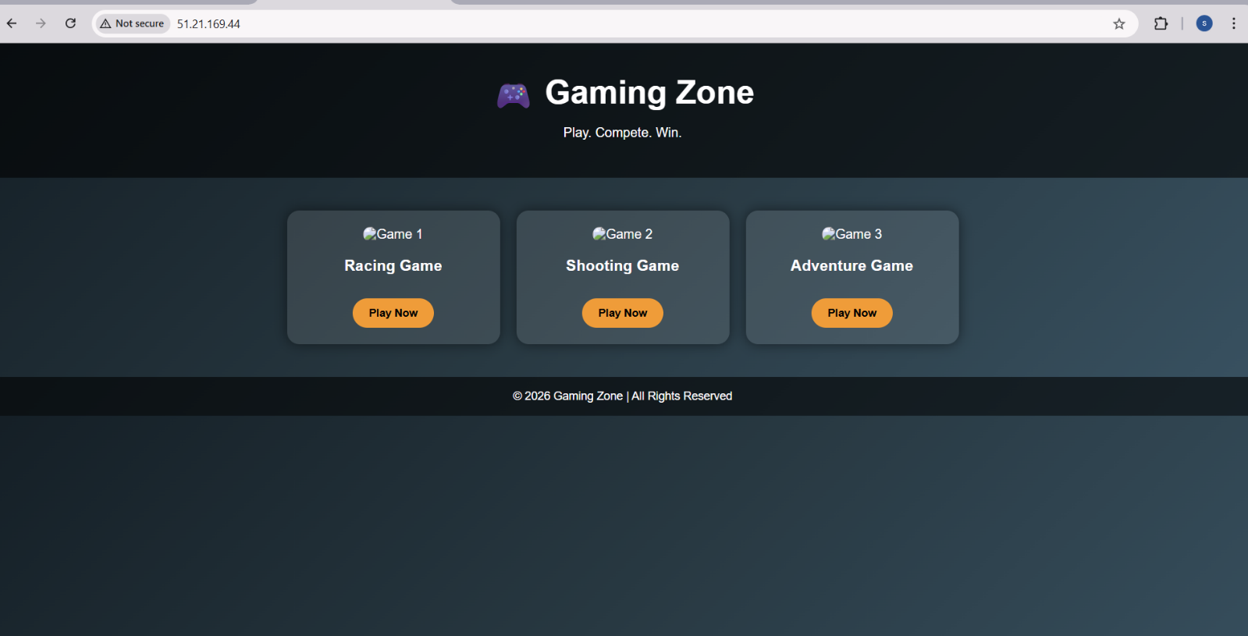

Challenges Faced
- Understanding security group rules
- SSH key permission issues
- Learning Apache directory structure

Key Learnings
- How to launch and manage EC2 instances
- Configuring AWS security groups
- Installing and managing Apache2
- Hosting a custom static website on AWS
- Basic cloud infrastructure handling

Conclusion
This project helped me understand real-world cloud deployment using AWS EC2. Deploying the Gaming Zone web application gave hands-on experience with Linux servers, Apache web hosting, and AWS networking.

